IDM Backup Manager V0.9.4 (Beta)
Please Remember this is Beta Version and may Contain Bug.
Copyright © 2012 Gajjar Tejas
http://gajjartejas26.blogspot.com

Help Content
- Introduction
- Features
- System Requirement
- Using IDM Backup Manager
  - Backing up IDM
    - Full Backup
    - Custom Backup
    - List Backup
  - Restoring IDM
  - IDM List Manager
    - Analyzing The File
    - Joining File
    - Removing File
    - Exporting List
  - IDM Cleaner
    - Custom Clean
    - Full Clean
- FAQ S and Important Notes
- Support, Contact & Bug Reporting

1. Introduction
IDM Backup Manager is free software that can backup files from Internet Download Manager and restore then later when you want. Also include cleaner and IDM List Manager. IDM List manager expert report in various format and allow force to join unfinished downloaded file and much more.

2. Features:
- Backup and Restore Whole Internet Download Manager
- Backup Custom elements for Backup like Setting, Unfinished Downloaded parts, Grabber data etc.
- Password protection backup file with AES Encryption.
- Variable compression rate, with six compressions Level.
- One click Backup and Restore
- Profile Conversion Support so it can be used with different Computer for backup and restore
- To Clean History, Logs and Unfinished Download Data Files.
- Download List Manager is allow to use Force to Join Unfinished Downloaded Files, Expert in various format, Remove Download from List and much more.

3. System Requirement:
- Windows 98, Windows xp, Windows vista and Windows 7 (x86 only)
- Intel Pentium 166MHz or above.
- Minimum 64MB memory.
- At least 5MB free hard disk space.

4. Using IDM Backup Manager

4.1 Backing up IDM

4.1.1 Full Backup
Open IDM Backup Manager and select Backup tab as shown in figure:
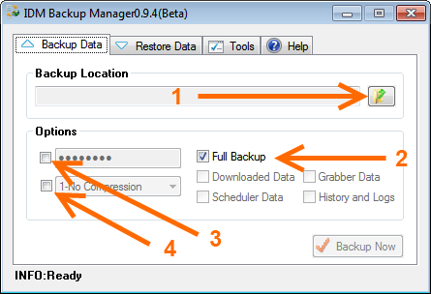
- Choose Folder you wish to save backup files
- Check Checkbox Full Backup
- Fill Password (optional)
- Choose Compression Level (optional)

4.1.2 Custom Backup
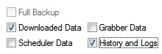
- Choose Folder you wish to save backup files
- For Custom Backup just uncheck Full Backup and Check as you want to backup shown in screenshot.
- Fill Password (optional)
- Choose Compression Level (optional)

4.1.3 List Backup
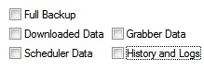
- Choose Folder you wish to save backup files
- For List Backup just uncheck all item as shown in figure. Please remember that in this backup mode no data will backup only IDM List will be backup.
- Fill Password (optional)
- Choose Compression Level (optional)

4.2 Restoring IDM
Open IDM Backup Manager and select Restore tab as shown in figure:
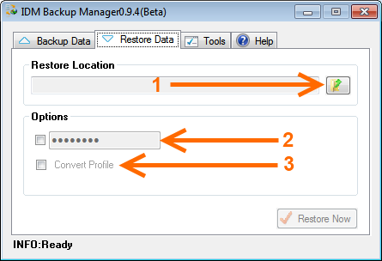
- Choose Folder where backup file exists. Make a sure backup file’s name is IDMbackup.7z.
- Choose password if it is encrypted.
- Choose Convert Profile options if backup is from another computer, user account or OS. You do not need to convert your native backup.

4.3 IDM List Manager
Go to Tools Menu and run IDM List Manager. It may take some time to analyze IDM List. Screenshots of IDM List Manager is shown below:
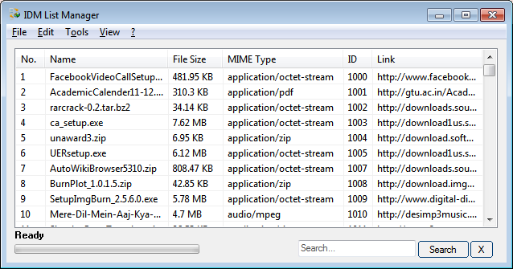

4.3.1 Analyzing the File
Press (File Menu -->Analyze) Analyze (Refresh) file to refresh status of:
- List According To Download:
  - List All Download
  - Finished Download
  - Unfinished Downloads and
  - Unfinished Download Data
- List According To Categories
  - All
  - Compressed
  - Documents
  - Music
  - Video and
  - Manually Created By User

4.3.2 Joining File
Point to List Only Unfinished Download and analyze then right click appropriate item to force join it as shown below screen shot.
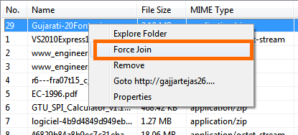

4.3.3 Removing File
Right click on item and Press remove to remove selected file item will deleted from IDM List. Be Careful!

4.3.4 Exporting List
Item will Currently on List will be exported. Then Click on Expert Button There is Four Mode as Shown in menu:
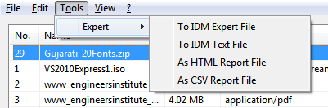
- AS html Report File
- As csv Report File
- To IDM Export File
- To IDM Text File

4.4 IDM Cleaner
Go to Tools Menu and run IDM Cleaner. IDM Cleaner is cleans the unfinished download, grabber data and History and Logs. IDM Cleaner will not remove IDM List. Be Careful!
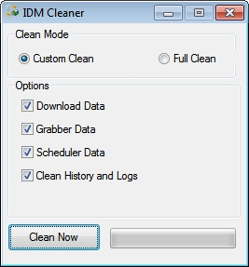
There are two modes:

4.4.1 Custom Clean
Clean Download data, Grabber data, Scheduler data, history and logs as per requirements. A conformation dialog will appear Press Yes to clean. Be Careful!

4.4.2 Full Clean
Clean Whole Folder. A conformation dialog will appear Press Yes to clean.

5. FAQS and Important Notes
- Please Close IDM then run backup/restore. Otherwise backup restore will unsuccessful.
- When you restore data Previous Profile will be override.
- Default there will be no compression on Backup file.
- When you reinstall os, move to other user account or backup file is another system you need to convert profile while restoring Backup.
- Make a sure backup file have correct name IDMbackup.7z while browsing (Restore Mode) IDMbackup.7z
- Is admin mode required for backup and restore data? Yes

6. Support, Contact and Bug Reporting
Email | : gajjartejas26@gmail.com
Website | : http://gajjartejas26.blogspot.com
Forum | :Link
Bug report | :Link or Email me


